2021 ASMD Directors Forum
February 7-9, 2021
Hosted Virtually on the ASTC Zoom Platform
Final Program
(Issued January 6, 2021)

The ASMD Program Committee (ASMD Vice Presidents William Harris of Space Center Houston, and Meg Beckel of the Canadian Museum of Nature) have developed a program tailored to the times for ASMD’s first, and hopefully last, virtual Directors Forum. Pre-registration for the meeting is required and registration forms and the final program were emailed today and are available on the ASMD website (http://asmd-us.org). Participation is restricted to active members and invited guests. Special thanks goes to our ASTC Zoom Platform Hosts, Christofer Nelson, ASTC President and CEO and Rachel Diamond, Ph.D., ASTC Chief of Staff.

Sunday February 7, 2021: Virtual Opening Happy Hour + a Half with ASMD President Joe Keiper, Virginia Museum of Natural History, Martinsville, Virginia

6:00-7:30 p.m. (Central Time). Informal gathering for all registered members and invited participants. Enjoy your own drinks and snacks and prepare to engage with your colleagues during the whole group welcome and lightning round 15 minute-breakout session with 6 colleagues at a time. Registered ASMD member directors will receive a complimentary Happy Hour Package from ASMD President Joe Keiper.

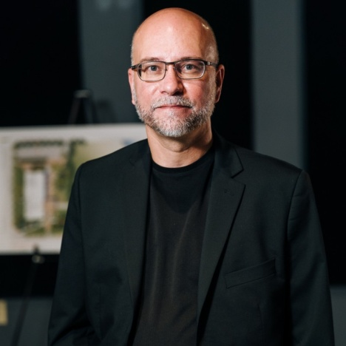
Joe Keiper, ASMD President

Monday, February 8, 2021: Pivot and Adjust to Covid 19: the Good, the Bad, and the Ugly Revealed.

1:00 p.m. Welcome and Opening Comments by ASMD President Joe Keiper

1:15-4:00 p.m. (Central Time). Participants will join the facilitated Breakout Session for the theme they selected during registration and then come back together for Facilitator Reports. Join an ASMD Board member in a Zoom Room; and let it all out. We will regroup and share experiences and strategies during the second part of the session.

1:15-2:45 p.m. Concurrent Breakout Theme Discussions:
1. Impacts of Covid-19 Pandemic on Staff Morale, Productivity and Future Planning
Facilitated by: Meg Beckel, ASMD Vice President, President and CEO, Canadian Museum of Nature, Ottawa, Ontario, Canada

2. Engaging with Your Stakeholders during a Global Pandemic
Facilitated by: Elizabeth Pierce, ASMD Secretary-Treasurer, President & CEO, Cincinnati Museum Center, Cincinnati, Ohio

3. Fundraising during a Global Pandemic — What worked? What failed? Who gave?
Facilitated by: Joe Keiper, ASMD President, Director, Virginia Museum of Natural History, Martinsville, Virginia

4. Re-forecasting for the Future of Earned Revenue without a Crystal Ball
Facilitated by: William Harris, ASMD Vice President, President & CEO, Space Center Houston, Houston, Texas

2:45-4:00 p.m.
Facilitators Report Back from Breakout Sessions to Whole Group

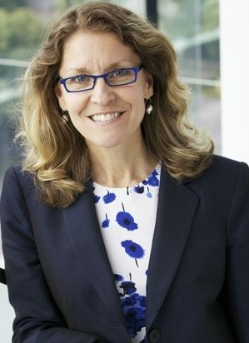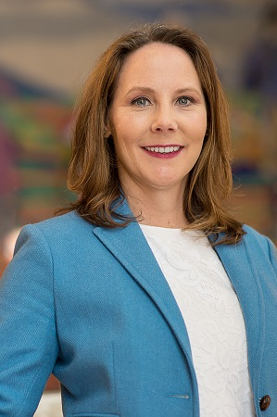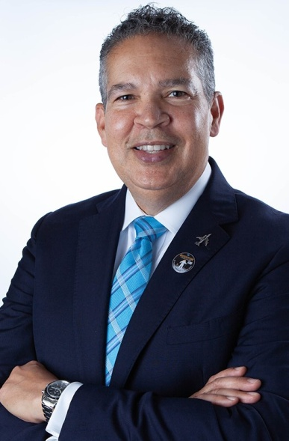
Meg Beckel Elizabeth Pierce William Harris

4:00 p.m. 15 Minute Break

4:15-5:45 p.m. (Central Time). ASMD Annual Business Meeting (for Members Only)

Tuesday, February 9. 2021: Well What’s Next? Alternative Revenue Streams during and after the Covid-19 Pandemic: Learn from Triumphs and Disasters.

1:00-4:15 p.m. (Central Time). Presentations of Case Studies, each followed by Discussion

1:00-1:30 p.m. In Person and Virtual Camps: Pacific Science Center Case Study
Will Daugherty, President and CEO, Pacific Science Center, Seattle, Washington

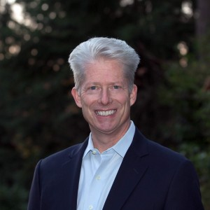

Will Daugherty

1:30-2:00 p.m. In Person and Virtual Camps: Arizona Science Center Case Study
Chevy Humphrey, President & CEO, Museum of Science and Industry, Chicago, Illinois

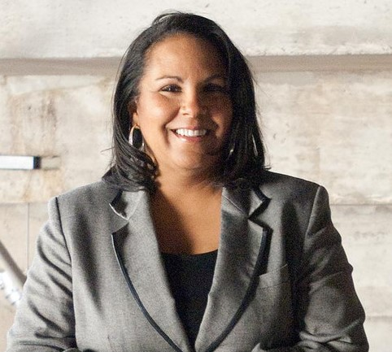
Chevy Humphrey

2:00-2:30 p.m. Science North and Ontario Science Centre Programming for Schools Contracted by Government
Guy Labine, CEO, Science North, Greater Sudbury, Ontario, Canada
Paul Kortenaar, CEO, Ontario Science Centre, Toronto, Ontario, Canada

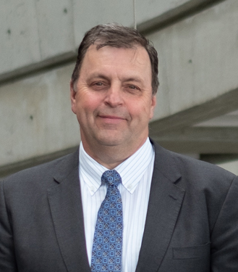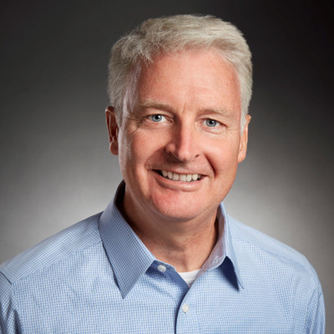
Guy Labine Paul Kortenaar

2:30 p.m. 15-minute Break

2:45-3:45 p.m. Creating and Monetizing a Digital Assets Strategy
Nik Honeysett, CEO and Director, Balboa Park Online Collaborative, San Diego, California
Jack Ludden, Senior Strategist and Innovation Specialist, Balboa Park, Online Collaborative

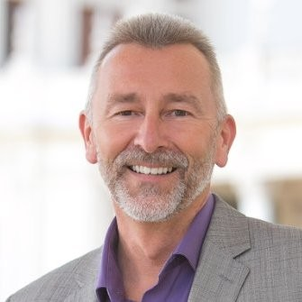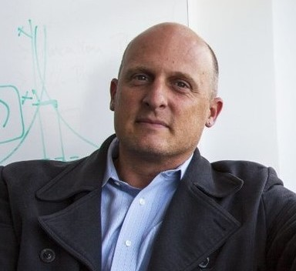
Nik Honeysett Jack Ludden

3:45-4:15 p.m. Monetizing Digital Experiences at Space Center Houston
William Harris, President & CEO, Space Center Houston, Houston, TX
Mary Baerg, Chief Operating Officer, Space Center Houston

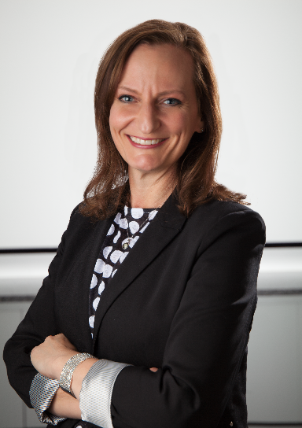
Mary Baerg
4:15 p.m. 15 minute break

4:30-5:00 p.m. (Central Time). Digest and Strategize Breakout Sessions
Participants are randomly divided into 6 Zoom Rooms. Each Zoom Room Group appoints a spokesperson and summarizes the most important take away messages from this Directors Forum.

5:00-5:30 p.m. (Central Time). Closing Session
ASMD President Joe Keiper calls upon the spokesperson for each Zoom Room Group to present their group’s two most important take away messages from this Directors Forum.

