Association of Science Museum Directors (www.asmd-us.org)
2024 Directors Forum in Washington D.C., Final Program (1/19/2024)

Dates and Transportation: ASMD 2024 Directors Forum Dates: February 21, 2024 (travel and evening reception) through February 24 (through 3:00 p.m. or later for optional visits).
You may want to stay in D.C. in the conference hotel after the Forum ends for self-guided museum visits (Feb. 24-late afternoon and February 25) and for National Museums Advocacy Day (Feb. 26-27). The hotel is 0.3 miles (a 10 minute walk) from Union Station. The closest airport to the conference hotel is Reagan National; it is only 5 miles (10-15 minute car ride) to our hotel. You may also fly into Dulles International Airport. It is 26 miles (45 minutes by car or 1.5 hours on public transportation) from the hotel. You might also consider flying into Baltimore-Washington International and taking the commuter train to Union Station and then walking to the hotel (about a one hour trip).

Conference Hotel: Hilton Washington DC Capitol Hill, 525 New Jersey Ave NW, Washington, D.C.

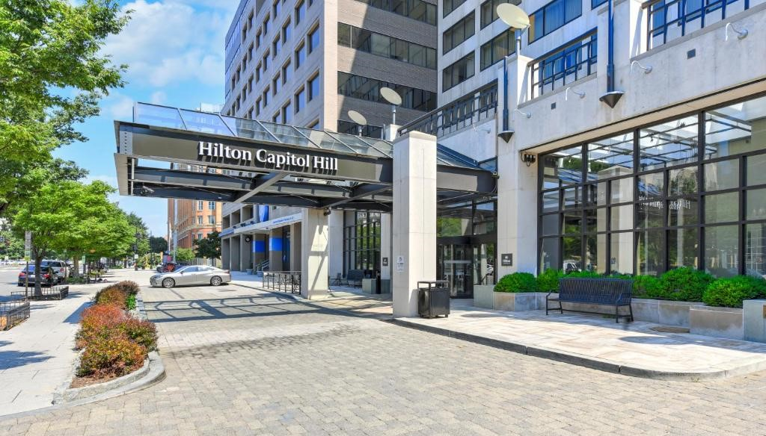

Conference rate: $229 per night plus tax for single or double occupancy. Reservation Link: https://book.passkey.com/gt/219511769?gtid=19f509885576b3abea1414e32894479
The reservation cutoff date to receive the contracted group rate is 12:00 a.m., Wednesday January 31, 2024. Valet parking (only option) is available at the rate of $59+tax per night.

If you want to remain in this hotel for National Museums Advocacy Day or want to check out later than February 25, please note that in the comments section in the linked reservation form and note the date you would like to check out. Please also email Bonnie Styles at asmd.styles@gmail.com because she needs to provide a list of individuals who would like to check out later than February 25 with names and checkout dates for each individual. The hotel will manually add the days later than February 25 for those individuals staying longer.

2024 Forum Hosts: Kirk Johnson, Sant Director, National Museum of Natural History and Christofer Nelson, President and CEO, Association of Science and Technology Centers, ASTC Offices, American Geophysical Union Building

2024 Directors Forum Program Committee: Joe Keiper, William Harris, Denise Young, Elizabeth Pierce, Todd Boyette, Bonnie Styles, Kirk Johnson, Christofer Nelson

WEDNESDAY, FEBRUARY 21: TRAVEL DAY AND OPENING GATHERING

5:00-7:00 p.m.: Informal Gathering in Hilton Washington DC Capitol Hill Bar. Members purchase their own drinks and snacks. Dinner is on your own. The restaurant in the hotel will be open.

THURSDAY, FEBRUARY 22, 2024 ASMD DIRECTORS FORUM: PROGRAM SESSIONS IN NATIONAL MUSEUM OF NATURAL HISTORY

7:00-8:20 a.m. Breakfast on your own
The hotel restaurant is open. Other options are available within walking distance.

8:20 a.m. Depart from Hotel for the National Museum of Natural History (NMNH)
You may choose to walk (one mile; ca. 22 minutes), or take an Uber, Lyft, or cab.
Use the Constitution Avenue Entrance for the NMNH on 10th Street and Constitution Ave NW, Washington, D.C. Do not use the National Mall entrance to the museum on Museum Drive because it will not be open at this time

8:50 Arrive at National Museum of Natural History for Full Day of Programs
Enter NMNH through the Constitution Avenue entrance and security. You must wear your ASMD Meeting Badge for entrance. The Museum does not open to the public until 10:00 a.m. Proceed to the Café and Glass Elevator. NMNH Staff members will key you up in the elevator to the Executive Conference Room at the beginning of the meeting. You’ll need to show your ASMD badge to the security officer posted in one of the elevators if you must leave and return the Executive Conference Room during the meeting.

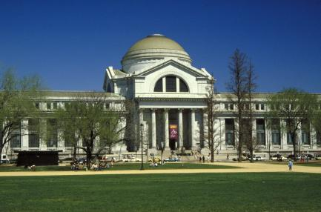
9:00 a.m. Welcome−NMNH Executive Conference Room
ASMD President Joe Keiper (left image below), Executive Director, Virginia Museum of Natural History, and Meeting Co-Host Kirk Johnson (right image below), Sant Director, National Museum of Natural History

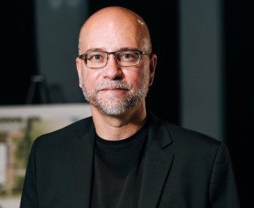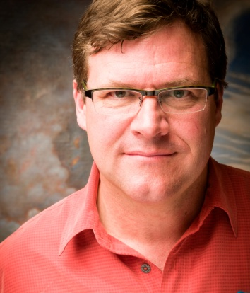

9:00-11:45 a.m.: Presentations on Issues in Museum Ethics and Responsibility, Executive Conference Room
Each presentation will be about 20 minutes long with 10 minutes for discussion following each presentation

9:15 a.m. National and International Repatriation, Shared Stewardship, and Ethical Returns: Dorothy Lippert, Program Manager, Repatriation Office, NMNH (image below)

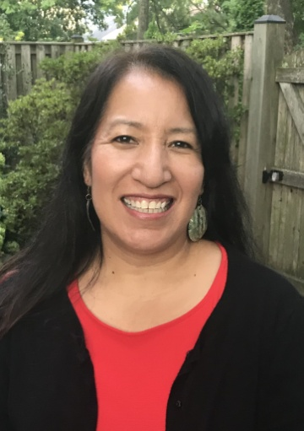

9:45 a.m. Decolonizing Museum Experiences and Providing First Peoples Perspectives: Silvia Singer, CEO and Director General, MIDE: Museo Interactivo de Economia, Mexico City, Mexico (image below)


10:15 a.m. Global Heritage Monitoring for Threatened Cultural Heritage Sites: Hayden Bassett, Assistant Curator of Archaeology, and Director, Cultural Heritage Monitoring Lab (Smithsonian Cultural Rescue Initiative), Virginia Museum of Natural History (image below)

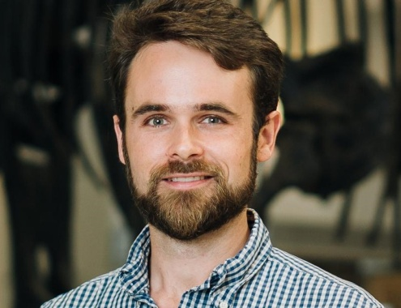

10:45 a.m. One World Collections and the Role of Natural History Museums: Making Museum Data Available to Address Major Issues: Kirk Johnson, Sant Director, NMNH (image below)

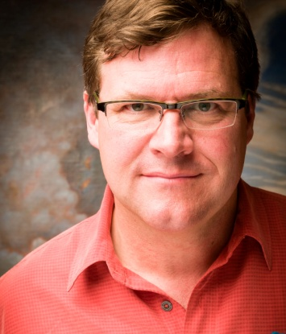

11:15 a.m. Embedding Climate Science in the Popular NMNH Deep Time Exhibition: Scott Wing, NMNH Research Geologist and Curator of Paleobotany (left image below), and Siobhan Starrs, NMNH Exhibition Developer and Project Manager (right image below)

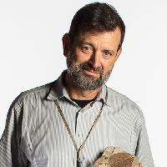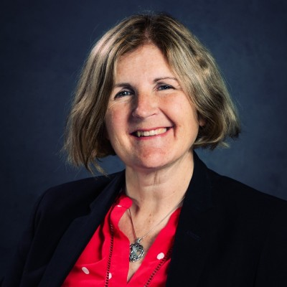

11:45 a.m. Break
Rest Rooms are available in the Executive Conference Room area. You’ll need to show your ASMD badge to the security officer posted in one of the elevators if you leave the meeting area.

Noon-1:30 p.m.: Lunch and Hot Topics Presentation by AAM and ASTC Leaders, Executive Conference Room
We will have a catered lunch in the Executive Conference Room. Participants will pick up their lunch outside the elevators and bring it back into the Conference Room.

12:30 p.m. Hot Topics Presentations BY ASTC AND AAM Leadership, Executive Conference Room

12:30 p.m. The ASTC Planetary Health Initiative: Christofer Nelson, ASMD Meeting Co-host and ASTC President and CEO (image below)

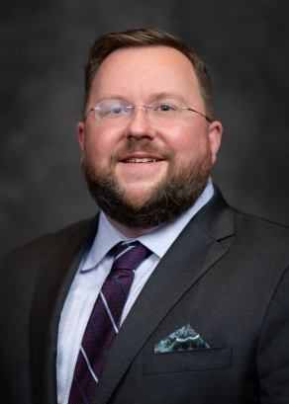

1:00 p.m. Moving Forward with DEAI and Social Impact: Brooke Leonard, Interim CEO and Chief of Staff, American Alliance of Museums (image below)



1:30-3:30 p.m.: Highlight Tours of NMNH Exhibitions with NMNH Experts and a NASA Colleague

1:30 pm. Second Floor Exhibition Highlight: Cell Phone: Unseen Connections: Josh Bell, NMNH Curator of Globalization (left image below), and Chrystina Solhan, NMNH Exhibition Developer and Project Manager (right image below)

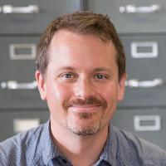
2:00 p.m. Second Floor Exhibition Highlight: NASA Hyperwall (Earth Observation Center): Mike Lawrence, NMNH Assistant Director for Exhibitions (left image below), and Eleanor Stokes, NASA Project Lead (right image below)

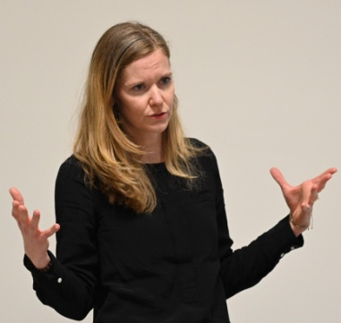

2:30 p.m. First Floor Exhibition Highlights in Deep Time Exhibition: Climate Curve, Pennsylvanian Coal Mine, Carbon Cycle Video, Age of Humans Gallery: Scott Wing, NMNH Research Geologist and Curator of Paleobotany, and Siobhan Starrs, NMNH Exhibition Developer and Project Manager (images on p. 4)

3:30-5:00 p.m.: Free Time in the NMNH
Explore other NMNH exhibitions or you may stay in or return to the Executive Conference Room to work or network with colleagues. If you want to return to the Executive Conference Room, you’ll need to show your ASMD badge to the security officer posted in one of the elevators to key you up to the Executive Conference Room. Before 5:00 p.m. you’ll need to retrieve all of your items from the Executive Conference Room and bring them to the reception in Q?rius. The Executive Conference Room will not be accessible after 5:00 p.m.

Recommended First Floor Exhibitions to Explore:
The David H. Koch Hall of Fossils-Deep Time
The Megalodon Shark (in the West atrium)
The Sant Ocean Hall
The David H. Koch Hall of Human Origins

Recommended Second Floor Exhibition to Explore:
Lights Out: Recovering Our Night Sky
Cell Phone: Unseen Connections
Objects of Wonder
The Janet Annenburg Hooker Hall of Geology, Gems, and Minerals

5:00-7:00 p.m.: Evening Reception and Dinner at the NMNH Q?rius Center
Our dinner is sponsored by NMNH and will be held in Q?rius, The Coralyn W. Whitney Science Education Center. At 5:00 p.m., participants should gather at the entrance to Q?rius on the west side of the NMNH lobby at the Constitution Avenue Entrance on the ground floor.

7:00 p.m. Return to the Conference Hotel (on your own)
There’s plenty of time to gather in the hotel bar to decompress.

FRIDAY, FEBRUARY 23: ASMD BUSINESS MEETING IN NMNH, TOURS OF NMNH MUSEUM SUPPORT CENTER (MSC), and PROGRAM SESSIONS IN AMERICAN GEOPHYSICAL UNION CONFERENCE CENTER

7:00 to 8:20 a.m. Have a Hearty Breakfast and Coffee on your own and depart for NMNH
By 8:30 a.m., ASMD Members need to walk or get transportation to the NMNH for the ASMD Business Meeting. Nonmember guests and significant others need to depart for the NMNH by 9:30 a.m. Please note that nonmember guests should not enter the NMNH, but gather outside the Constitution Avenue entrance to catch the bus.

9:00-10:00 a.m.: ASMD Business Meeting (ASMD Members Only) in the NMNH Executive Conference Room
Enter the Museum through the Constitution Avenue Entrance and security and gather at the glass elevator to be keyed up to the Conference Room

10:00 a.m.-10:15 a.m.: Board and Depart in Bus for NMNH Museum Support Center
All participants should arrive at the NMNH 10th Street and Constitution Ave Entrance area outside the museum. An Abe’s Transportation Center Bus will be pulled over on the street in this area to transport participants to the NMNH’s Museum Support Center, 4210 Silver Hill Road, Camp Springs, Maryland. The bus will depart at 10:15 a.m.

10:15 a.m. Overview of the Museum Support Center
Kirk Johnson, Sant Director, NMNH, will provide an overview of the Museum Support Center on the bus while we are in transit.

11:00 a.m. Arrive at the Museum Support Center Entrance

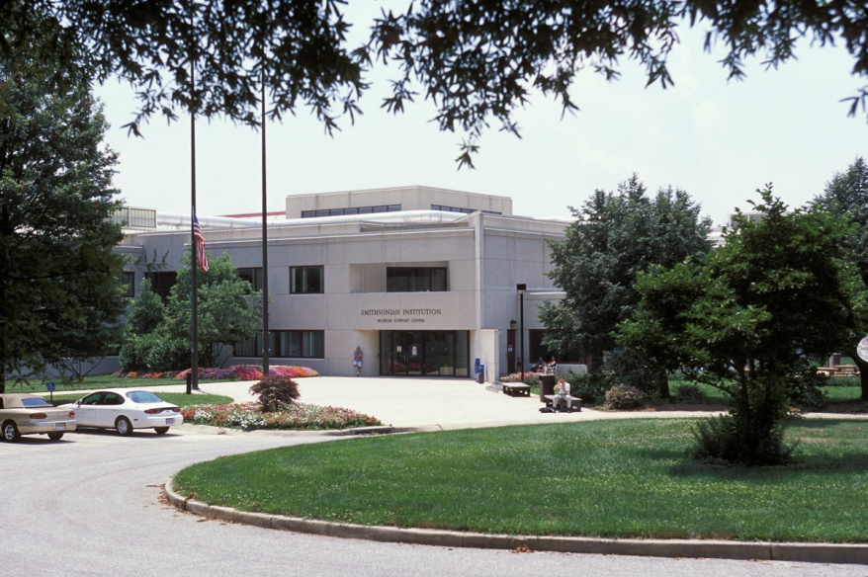

11:00 a.m. - 12:30 p.m. Highlight Tours of MSC with NMNH Leaders.

11:00 a.m. Welcome to the MSC: Carol Butler, NMNH Assistant Director for Collections, and JR Smith, NMNH MSC Manager

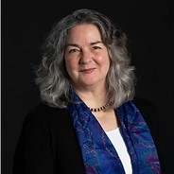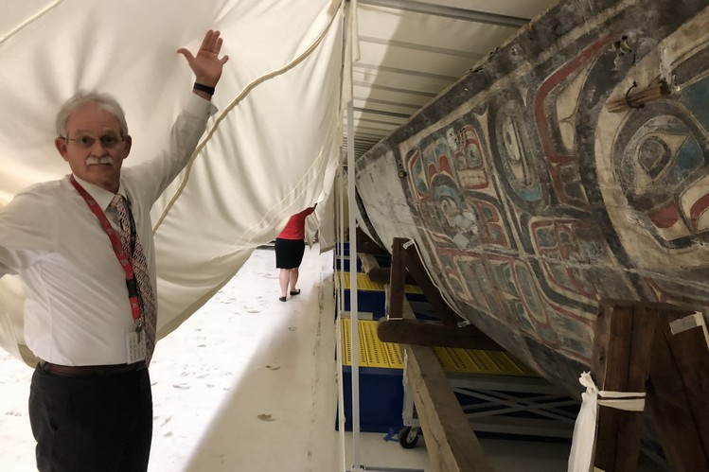

Following the welcome, participants will divide into three groups and spend 90 minutes cycling through three areas in the MSC to view facilities and collections and hear about related issues with NMNH research and collections staff members.

Pod 3: Biorepository, Antarctic Meteorites, and USGS Orphan Collection: Kathy Hollis, NMNH Collections Manager; Cari Corrigan, NMNH Curator of Meteorites; and Chris Huddleston, NMNH Biorepository Manager (images below)

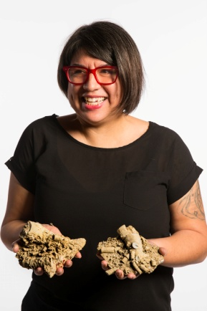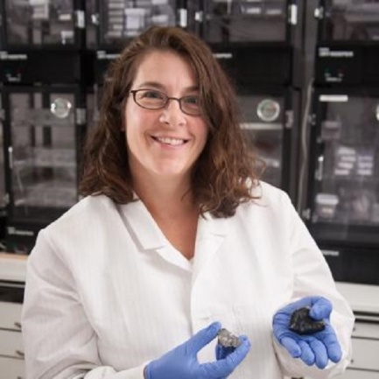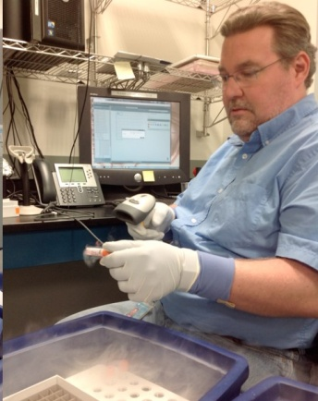

Pod 4: Oversized Collections: Torrey Rick, NMNH Curator of North American Archaeology, and Carrie Beauchamp, NMNH Collections Manager

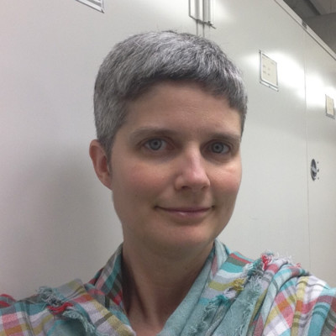

Pod 5: Wet Collections: Bill Moser, NMNH Collections Manager

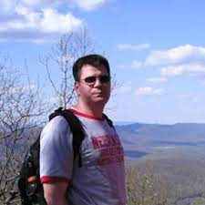

12:30 p.m. Board Bus at MSC entrance to go to American Geophysical Union (AGU) Building, 2000 Florida Ave, NW, Washington DC

1:15 p.m. Arrive at AGU/ASTC Offices Building and Conference Center
Welcome by host Christofer Nelson, ASMD Meeting Co-host and President and CEO, Association of Science and Technology Centers.

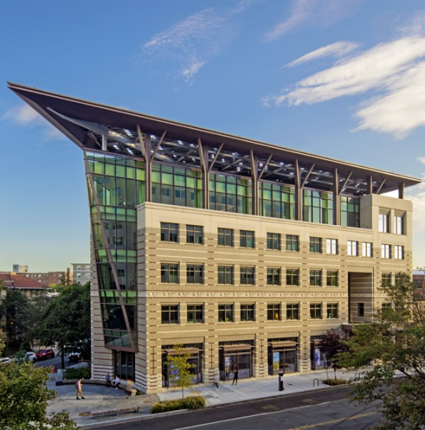

We will have a catered lunch in the Conference Center before our programs begin.

2:15 p.m. Panel Discussion: Innovations in Public Engagement to Advance Planetary Health
This year’s panel discussion will focus on museum innovations in public education and engagement on planetary health, encompassing key issues such as climate change, biodiversity, pollution, and environmental justice. Panelists will include Ellen Stofan, Under Secretary for Science and Research, Smithsonian Institution; and Rose Hendricks, Research Director for ASTC’s Seeding Action initiative. Panelists will share insights on the latest strategies and initiatives aimed at educating and engaging the public through exhibits, programs, research, and community partnerships.

As the Under Secretary for Science and Research for the Smithsonian Institution, Ellen Stofan (image below) oversees the Smithsonian’s science research centers and the National Air and Space Museum, National Museum of Natural History, and the National Zoo and Conservation Biology Institute, as well as the Smithsonian Libraries and Archives, Office of International Relations, the Smithsonian Scholarly Press, and the Scientific Diving Program. She focuses on the Smithsonian’s “Our Shared Future: Life on a Sustainable Planet Initiative.” She previously served as the John and Adrienne Mars Director of the National Air and Space Museum from 2018-2021 and initiated their seven year renovation of the facility in Washington D.C. She served as the Chief Scientist for NASA from 2013-2016. Before coming to the Smithsonian, she had more than 25 years experience in space-related organizations and a strong research background in planetary geology. She received her Bachelor’s degree from William & Mary and her Master’s and Doctoral degrees from Brown University, all in geological sciences. Her personal research focuses on the geology of Venus, Mars, Saturn’s moon Titan, and Earth.

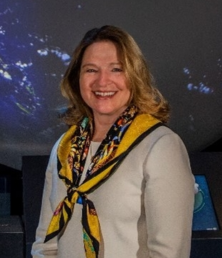

Rose Hendricks (image below) joined the ASTC staff in 2022. She is currently serving as the Research Director for their new Seeding Action Initiative to support science centers, museums, and other public engagement networks to cultivate a culture of hope and action on planetary health issues such as climate change, biodiversity loss, and pollution. Rose is a cognitive and social scientist who studies public views of complex societal issues. This research provides a foundation for the scientific community to more effectively engage with public audiences, ensuring that science not only informs, but is also informed by societal priorities. Before coming to ASTC she served as an instructor and cognitive scientist at UC San Diego, was a researcher and research fellow for the FrameWorks Institute, was selected as the Kavli Science Fellow to develop a collective impact initiative among scientific societies in the San Diego area to facilitate broader public engagement, and was the Program Director for the Society for Civic Science Initiative for the Society of Cell Biology. She has a Bachelor of Arts degree in cognitive Science from Vassar College and a Ph.D. in cognitive science from UC San Diego.



3:15 p.m. Break

3:30 p.m. Net Zero Tour of AGU Building
Mathew Boyd, AGU’s Net Zero Building Operations Director (image below), will give us a tour highlighting the recent conversion of the building to Net Zero. Following the tour, we will head back to the Conference Center.

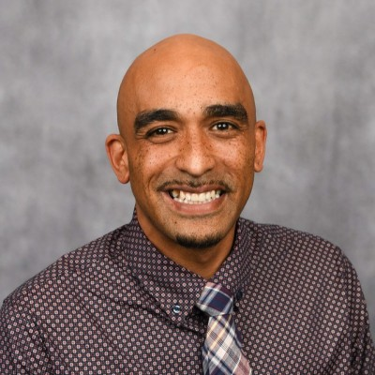

4:30 p.m. Fireside Chat with Sudip Parikh, Chief Executive Officer of the American Association for the Advancement of Science, and Cristin Dorgelo, a highly experienced independent management consultant and former President & CEO of ASTC, on Landscaping Science Research, Policy, and Engagement

Cristin Dorgelo, an expert in leadership and management with experience leading science and innovation organizations in the public and private sector, will facilitate and participate in a Fireside Chat with Sudip Parikh, Chief Executive Officer of the American Association for the Advancement of Science and executive publisher of the Science family of journals. The conversation will consider U.S. science policy and R&D funding, scientific diplomacy and global science collaboration, advancement of equity in STEM, and public engagement in science.

Sudip Parikh (image below) became the CEO of the American Association for the Advancement of Science (AAAS) and executive publisher of the Science family of journals in January 2020. Parikh has spent over two decades at the intersection of science, policy, and business as a Senate staffer, life science business leader, and a leader in the policy community. Prior to his position at AAAS, he was senior vice president and managing director at DIA Global, a multidisciplinary organization for healthcare product development. Prior to his work with DIA, Parikh was a vice president at Battelle, a multimillion dollar research and development organization, where he led two business units with over 500 scientific, technical, and computing experts performing basic and applied research, developing medicines and healthcare devices and agricultural products, and creating advanced analytics and artificial intelligence applications to improve human health. From 2001 to 2009, Parikh served as science advisor to the Republican Leadership in the U.S. Senate Appropriations Committee, where he was responsible for negotiating budgets for scientific and health agencies. He is an active member of the scientific advocacy community and serves on numerous boards. He is the co-chair for the Science and Technology Action Committee, Science CEO Group, and the Coalition for Trust in Health and Science. He is an elected member of the American Academy of Arts and Sciences and the Council on Foreign Relations. He has received numerous public service awards. Early in his career he was awarded a National Science Foundation Graduate Research Fellowship while earning his Ph.D. in macromolecular structure and chemistry from the Scripps Research Institute in La Jolla, California. He earned his B.S. in applied science from the University of North Carolina at Chapel Hill.
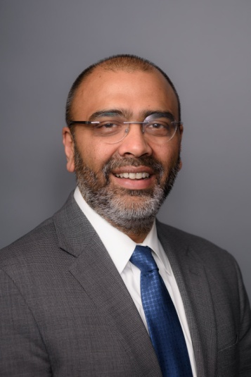
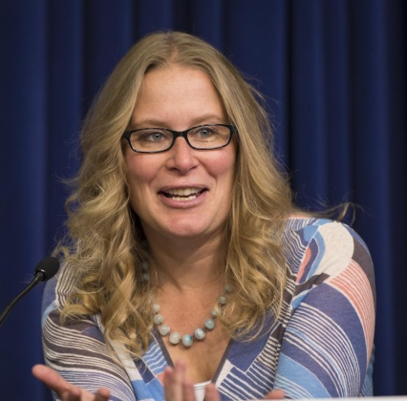
Cristin Dorgelo (image above) has more than 25 years of executive leadership experience and is known for helping organizations turn ambitious ideas into meaningful outcomes. In 2023, the Federation of American Scientists named her as Senior Fellow, who will focus on advancing government innovation and capacity to deliver solutions to the pressing problems our nation faces. Cristin served from January 2021 to January 2023 as the Senior Advisor for Management at the Office of Management and Budget (OMB) within the Executive Office of the President. In this role, she drove initiatives and led teams across six offices within OMB, and co-led development and implementation of the Biden-Harris Administration’s Management Agenda. From 2018 to 2020, Cristin was the President and CEO of the Association of Science and Technology Centers, where she advanced ASTC’s vision of increased understanding of–and engagement with–science and technology among all people, as well as its mission to champion and support science and technology centers and museums. She served at the White House Office of Science and Technology Policy as Chief of Staff, from 2014 to 2017, and as the Assistant Director for Grand Challenges, from 2012 to 2014, facilitating policy development and implementation across myriad science and technology issues, with a particular focus on open-innovation approaches and cross-sector collaboration to address grand challenges. From 2006 to 2012, Cristin was Vice President of Prize Operations for XPRIZE, a nonprofit that uses large-scale global incentive competitions to crowd source technology solutions. She helped launch several technology startup companies at the Pasadena, California incubator Idealab from 2000 to 2006, including participation on the founding team of X1 Technologies. Cristin began her career at Times Mirror in organizational development and at the Los Angeles Times in advertising operations. She holds a B.A. in history with a minor in anthropology from UCLA.

5:15 p.m. Reception and Dinner in the AGU BUILDING
This reception and dinner is hosted and sponsored by ASTC.

Return to Conference Hotel
Following the dinner, participants will make their own way back to hotel by walking, or by taking the metro (directions will be provided), or by Uber, Lyft, or shared cabs. There will plenty of time to gather in the hotel bar for further discussions with colleagues.

SATURDAY, FEBRUARY 24: VISIT TO THE NATIONAL AIR AND SPACE MUSEUM AND THE NATIONAL ART GALLERY WITH LEADERSHIP

7:00 to 8:20 a.m. Breakfast on your own

8:30 a.m. Depart for the National Air and Space Museum (NASM) Entrance
NASM is located on 6th Street and Independence Ave SW, Washington DC. The public entrance is on Independence Ave. You may choose to walk (0.9 miles, 20 minutes), or take an Uber, Lyft, or shared cab. It is important to arrive at the Museum Public Entrance by 8:50-8:55 a.m. to gain entrance because the Museum does not open to the public until 10:00 a.m.

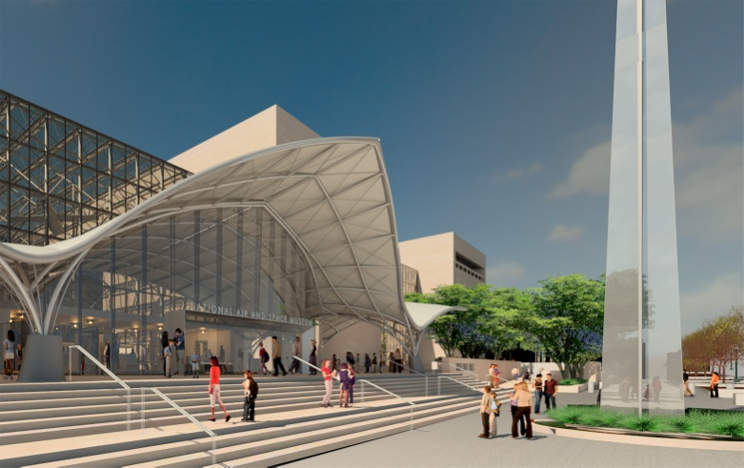

9:00 a.m. Overview of Renovations of the Entire NASM Building: Christopher Browne, John and Adrienne Mars Director of the National Air and Space Museum (image below)
Director Browne will provide us with an overview of the ongoing, multi-year, complete re-imagination and renovation of all the exhibitions in the museum building in Washington DC.

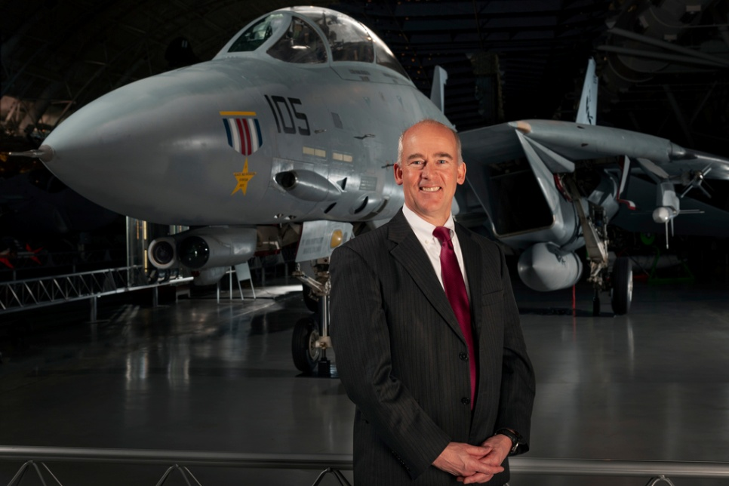

Christopher Browne is the John and Adrienne Mars Director of the Smithsonian’s National Air and Space Museum. Browne joined the museum as deputy director in 2017 and served as acting director from 2021 to 2022, when he was named director. He has helped lead the museum’s multi-year renovation of its flagship building in Washington, D.C. Browne served as a naval flight officer in the U.S. Navy, flying F-14 Tomcats off the USS Dwight D. Eisenhower, making numerous deployments to the Mediterranean, North Atlantic, and Caribbean during seven years of active service. He amassed over 1,400 flight hours and more than 300 carrier landings, and he is a graduate of the U.S Navy’s “Top Gun” Fighter Weapon School. In 1988, Browne served in Operations at Ronald Reagan Washington National Airport until selected as the airport manager in 1988. He managed National Airport for seven years, a period that included significant construction and the Y2K and 9/11 events. He accepted the airport manager position at Washington Dulles International Airport in 2005. Here he managed a staff of over 500 employees and was responsible for an aviation revenue stream exceeding $400 million, as well as the revenues generated on the Dulles Toll Road used to construct the WMATA Metrorail line to Dulles. He holds a B.A in history from Dartmouth College and a M.S in aeronautics from Embry-Riddle Aeronautical University. He serves on the Boards of the Space Foundation and Aero Club of Washington.

9:30 a.m. to 11:00 a.m. Visit Re-imagined Exhibitions with NASM Docents
We will break into groups and visit a selection the eight renovated exhibitions that opened in October 2022. Museum Docents will highlight aspects of some of the following exhibitions and you will have the opportunity to visit the others during your free time:

Early Flight
America by Air
Destination Moon
Nation of Speed
The Wright Brothers & the Invention of the Aerial Age
Kenneth C. Griffin Exploring the Planets Gallery
Thomas W. Haas We All Fly
One World Connected (image below)

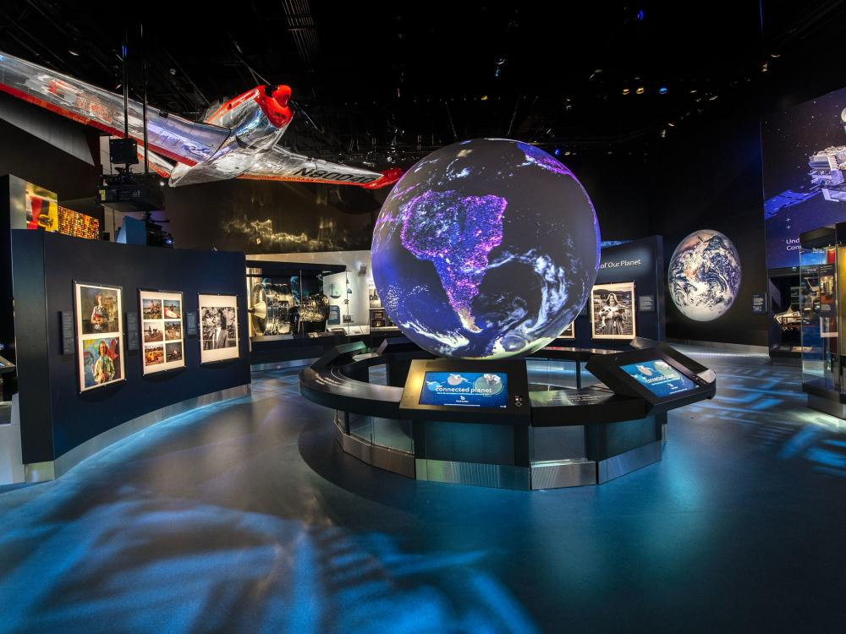

11:00 a.m.-2:00 p.m. Free Time in NASM and Lunch on Your Own
You will have time to further explore the newly renovated exhibitions in the National Air and Space Museum, as well as the gift shop and the Mars Cafe. You may want to have lunch in the Mars Cafe or head to our next venue and have lunch in the National Gallery of Art Cascade Café (which includes an espresso and gelato bar).

2:00-3:00 p.m. Highlight Tour of the National Gallery of Art: Laura Lott, Administrator & Chief Operating Officer, National Gallery of Art, and former President and CEO of AAM.
Participants will walk (0.4 miles, 9 minutes) to the National Gallery of Art’s West Entrance at 6th St and Constitution Avenue. Participants will meet in the Rotunda of the West Building, which is straight inside the Constitution Avenue entrance.

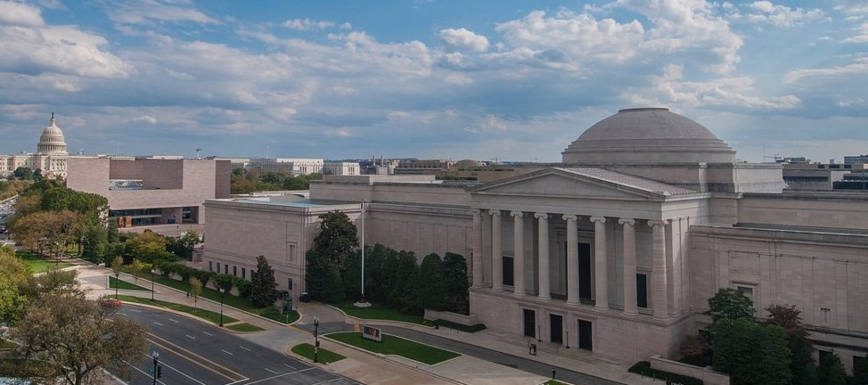

In July 2023, Laura Lott (image below) assumed a new position as the Administrator & Chief Operating Officer for the National Gallery of Art. In this role, she serves on the Museum’s senior leadership team and oversees administrative support, architecture and capital improvement, facilities, horticulture, sustainability strategies, personnel, procurement, and security. She is known throughout the museum community for her exemplary service as President and CEO of the American Alliance of Museums from 2015-2023. She served as the AAM’s COO and CFO from 2010-2015. She was the first woman director in AAM’s 110 year history. She spearheaded major initiatives resulting in improvements in many areas at AAM and throughout the museum community. The national Museum Accreditation and Excellence Programs, based at AAM, were improved by bringing applications online and reviewing standards and best practices, and the selection and composition of the Accreditation Commission, which reviews applications. She raised awareness of social inequities in museums, and under her leadership, staff diversity and inclusiveness increased for AAM and for many museums throughout the country. She established the AAM’s first Diversity, Equity, Accessibility, and Inclusion Office. She also launched an initiative to promote diversity and inclusion on museum boards, and diversified the AAM Board as well. She expanded AAM’s advocacy efforts and collaboration with other Museum Associations to help secure significant federal relief funding for museums, especially during the pandemic. Laura has a B.S. in business from American University. She is a CPA and is also a private pilot.

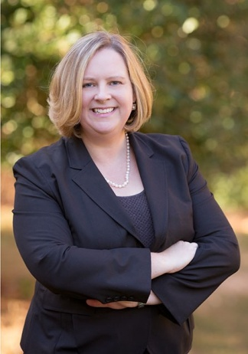

3:00 P.M. DIRECTORS FORUM OFFICIALLY ENDS, BUT YOU MAY WANT TO STAY LONGER!
You may choose to check out of the conference hotel on February 24 and fly out in the evening after our programs end or checkout and depart on February 25. However, you may want to check out later. Here are some options for your consideration.

SATURDAY, FEBRUARY 24 (P.M.) AND/OR SUNDAY, FEBRUARY 25: OPTIONAL SELF-DIRECTED VISITS TO THE NATIONAL MUSEUM OF AFRICAN AMERICAN HISTORY AND CULTURE, NATIONAL MUSEUM OF THE AMERICAN INDIAN, AND THE NATIONAL MUSEUM OF AMERICAN HISTORY
Katie Roper, Office of Sant Director, National Museum of Natural History, has volunteered to help secure free timed tickets to the National Museum of African American History and Culture for members who would like to visit on Saturday afternoon or Sunday. The National Museum of the American Indian and the National Museum of American History do not require timed tickets. Members should indicate their interest in visiting these museums on the registration form. More information about visiting these museums is available at: https://www.si.edu/visit.

MONDAY, FEBRUARY 26 AND TUESDAY, FEBRUARY 27: OPTIONAL STAY FOR NATIONAL MUSEUMS ADVOCACY DAY

Please let Bonnie Styles (asmd.styles@gmail.com) know as soon as possible if you are staying for Advocacy Day and/or would like to stay in the ASMD Conference Hotel beyond February 25, and if so, what day you would like to check out.

