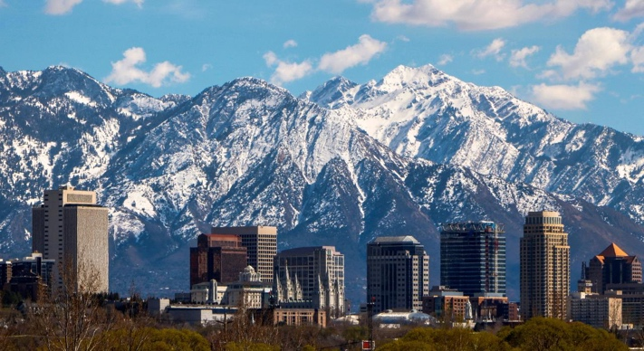
ASMD 2025 DIRECTORS FORUM
SALT LAKE CITY, UT
Feb. 2-5, 2025
Final Program

Updates on ASMD Website: https://asmd-us.org
Send questions to asmd.styles@gmail.com

Dates and Transportation: The Association of Science Museum Directors 2025 Directors Forum will be held in Salt Lake City, Utah, from Sunday, February 2, 2025 (travel and optional evening gathering) to Wednesday, February 5 (ends at noon, so mid- to late afternoon or evening return flights are possible). Arrange your flights to the Salt Lake City International Airport (airport code: SLC) and transport from SLC to the conference hotel via taxi, Uber, or Lyft.
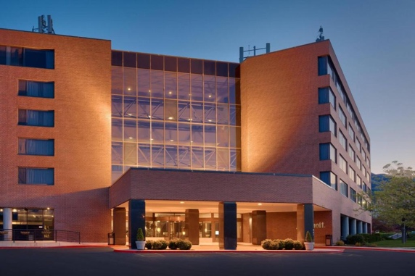
Conference Hotel: Marriott Salt Lake City at University Park, 480 Wakara Way, Salt Lake City, UT 84108
- ASMD has a hotel block with a room rate of $179 including breakfast. You may reserve your room in the room block for additional days before or after the conference at the conference rate if rooms are available.
- Follow this link to make your hotel reservation online and enter the dates for your stay: https://www.marriott.com/events/start.mi?id=1721247690430&key=GRP
- To make reservations with a reservations agent, call 1-800-228-9290 and reference the ASMD Directors Forum to get a room in our hotel block at our rate.

2025 Forum Host and Sponsors:
- Jason Cryan, The Sarah B. George Executive Director, Natural History Museum of Utah
- PGAV Destinations, dinner sponsor
- Cosm, dinner and venue sponsor

2025 Directors Forum Program Committee: William Harris, Jason Cryan, Bonnie Styles

FINAL PROGRAM (Updated January 27, 2025)

Sunday, February 2, 2025

- 5:00 pm: Optional Informal Gathering in Marriott Hotel Bar
  - Members purchase their own drinks and snacks
  - Members are on their own for dinner. You may choose to eat in the hotel restaurant or take Uber, Lyft, or taxi to local restaurants.

Monday, February 3, 2025
- 7:00-8:00 am: Breakfast in Hotel (included in your room reservation)
- 8:00-8:15 am: Transport to the Natural History Museum of Utah. Options include riding in NHMU vans or walking (0.5 mile, uphill).
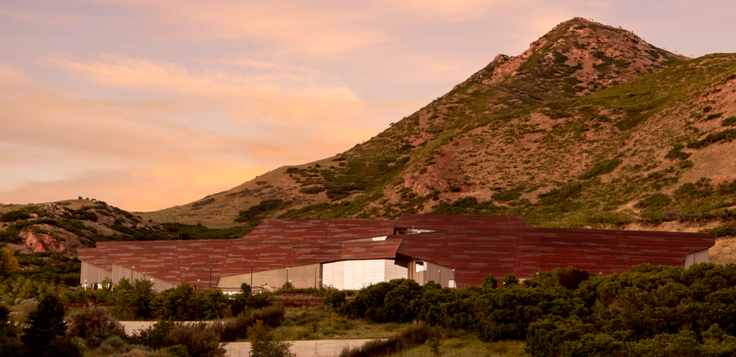

- 8:30 am: Welcome from ASMD President William Harris, President & CEO of Space Center Houston, and Conference Host Jason Cryan, The Sarah B. George Executive Director of the Natural History Museum of Utah
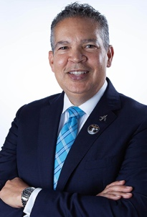
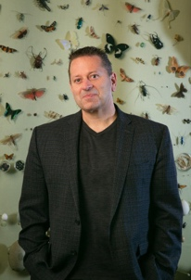
William Harris
Jason Cryan

- 8:45-10:30 am: Session 1 – Taking Action on Climate and Sustainability.
  - Bonnie Baxter: What’s Happening with the Great Salt Lake?
  - Lynne Zummo and Lisa Thompson: the NHMU Climate of Hope Exhibition
  - Chris Eisenberg: Working Towards Carbon Neutrality at NHMU
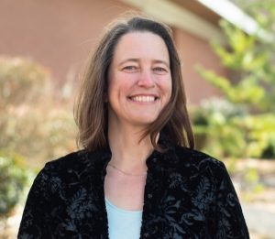
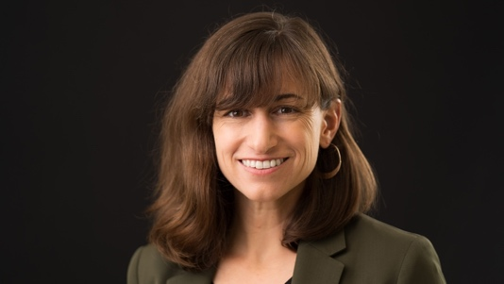
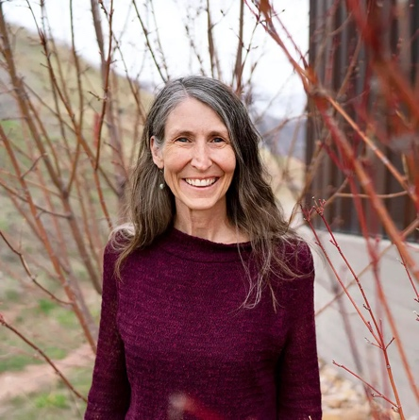
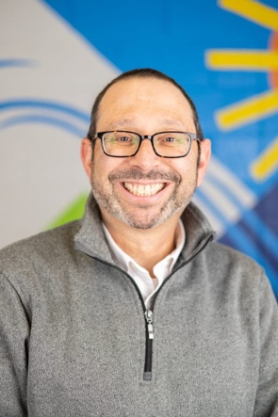
Bonnie Baxter
Lynne Zummo
Lisa Thompson
Chris Eisenberg

- 10:30-10:45 am: Break

- 10:45-11:45 am: Session 2 – Whose Science is it Anyway? Considering Indigenous Perspectives on Science. Panel and Group Discussion with Chevy Humphrey (President & CEO, Griffin Museum of Science and Industry), Lori Bettison-Varga (President & Director, Natural History Museum of Los Angeles County), and Polly Olsen (Director, DEAI & Decolonization and Tribal Liaison, Burke Museum).
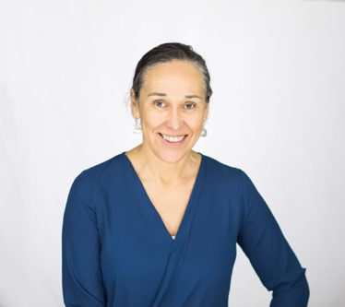
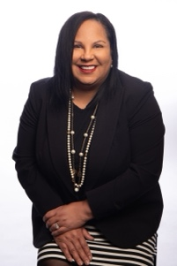
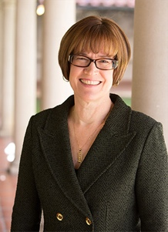
Polly Olsen
Chevy Humphrey
Lori Bettison-Varga

- Noon-1:00 p.m.: Catered lunch at NMNH (included with registration)

- 1:00 pm: Board bus for the scenic ride through the mountains to Park City, Utah

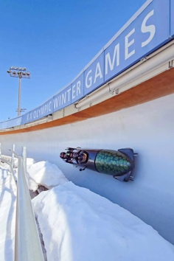
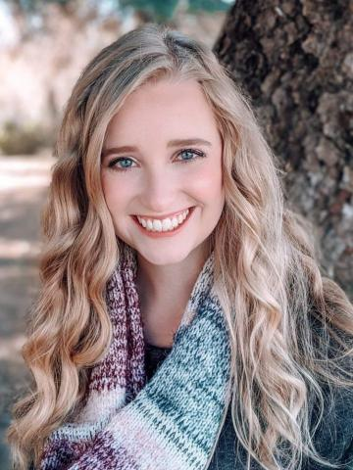
- 2:00-4:00 pm: Tour of the Utah Olympic Park with Annie Bommer, Executive Director of the Alf Engen Ski Museum. The Utah Olympic Park, located outside of Park City, Utah, was built for the 2002 Winter Olympics and hosted the 2002 bobsleigh, skeleton, luge, ski jumping, and Nordic combined events. Today, the Park serves as a training center for Olympic and development level athletes, as well as a recreational highlight in the state. In addition to the sports facilities, the Park houses the Alf Engen Ski Museum and the Eccles Salt Lake 2002 Olympic Winter Games Museum. With the announcement that Salt Lake City will host the 2034 Winter Games, the Utah Olympic Park will again host various events.
Annie Bommer

- 4:00 pm: Board bus for return to Marriott Hotel

- 5:00-6:00 pm: Time to freshen up and relax in the Marriott Hotel

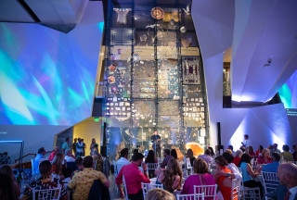
- 6:15 p.m.: Board bus for transport to the Natural History Museum of Utah. Option includes walking (0.5 mile, uphill).

- 6:30-8:30 pm: Cocktail reception and dinner in NHMU’s Canyon sponsored by PGAV Destinations

- 8:30 pm: Transport back to the Marriott Hotel.
Options include riding in NHMU vans or walking (0.5 mile, downhill).

Tuesday, February 4, 2025
- 7:00-8:00 am: Breakfast in Hotel (included in your room reservation)
- 8:00-8:15 am: Transport to the Natural History Museum of Utah. Options include riding in NHMU vans or walking (0.5 mile, uphill).

- 8:30-9:30 am: ASMD Business Meeting. ASMD Members only; guests may join a separate activity in the NHMU at this time.

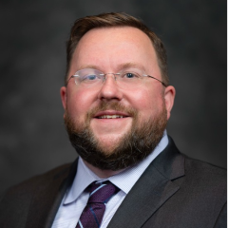
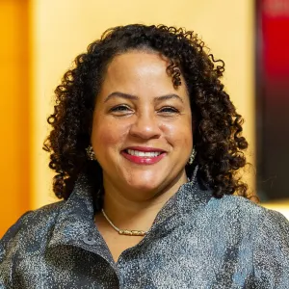
- 9:35-10:45 am: Session 3 – Fireside Chat on Grand Challenges Facing Museums. ASMD President William Harris will facilitate this discussion including Christofer Nelson (President & CEO of the Association of Science & Technology Centers) and Marilyn Jackson (President & CEO of the American Alliance of Museums).
Christofer Nelson
Marilyn Jackson
William Harris

- 10:45-11:00 am: Break

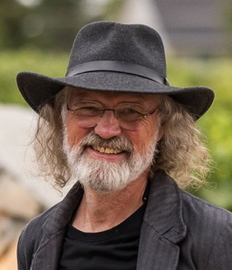
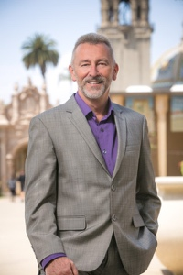
- 11:00-noon: Session 4 – Lunch and Learn on Impacts and Opportunities Posed by Artificial Intelligence. Enjoy lunch (included in your registration) during a facilitated conversation about the challenges and opportunities related to machine learning and AI with Nik Honeysett (Director & CEO of the Balboa Park Online Collaborative) and Rob MacLeod (Deputy Director of the Scientific Computing and Imaging Institute, University of Utah).
Rob MacLeod
Nik Honeysett

- 12:00 pm: Board bus to Ogden, UT

- 1:00-3:00 pm: Tour of the Hill Aerospace Museum with Director Aaron Clark. This AAM-accredited, military aviation museum located at Hill Air Force Base has more than 70 aircraft on display and is among the US Air Force’s largest aerospace museums.
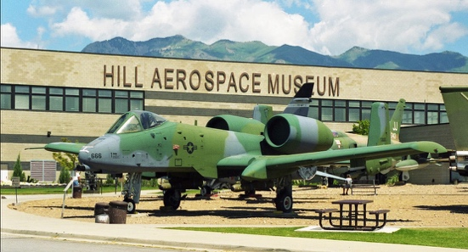
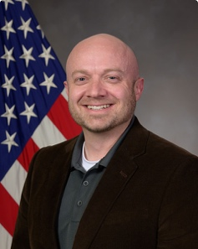
Aaron Clark

- 3:00 pm: Board the bus for the return trip to the Marriott Hotel
- 3:45-4:45 pm: Time to freshen up and relax in the Marriott Hotel
- 4:45 pm: Board the bus or walk (0.5 miles) to the Cosm Experience Center

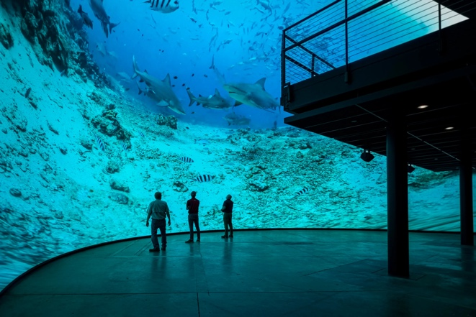
- 5:00: Cosm Experience in the Cosm Experience Center. This prototype for dome experiences and Cosm Venue built by the well-known Cosm global technology company in Salt Lake City delivers immersive experiences.

- 6:00-8:00 pm: Drinks and Dinner in the Dome hosted and sponsored by Cosm

- 8:00 pm: Board the bus (or walk) to the Marriott Hotel

Wednesday, February 5
- 7:00-8:30 am: Breakfast in Hotel (included in your reservation)
- 8:30-8:45 am: Transport to the Natural History Museum of Utah. Options include riding in NHMU vans or walking (0.5 mile, uphill).

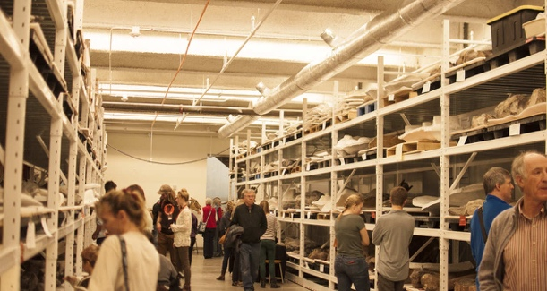
- 9:00 am-noon: Session 5 – NHMU Deep Dive. To wrap up the ASMD Forum, Jason Cryan and his leadership team will lead a presentation and tours of the host organization, the Natural History Museum of Utah.
Jason Cryan

- Noon: Farewell and Transport back to Marriott Hotel. Options include riding in NHMU vans or walking (0.5 mile, downhill).
You may choose to depart to the airport for late afternoon or evening flights or spend another night or two in the hotel to extend your stay in Salt Lake City.

